Cover Page

Wai Mun Liew

8214

CSCI 331-33

Project 1

3/12/2018

ER Diagram

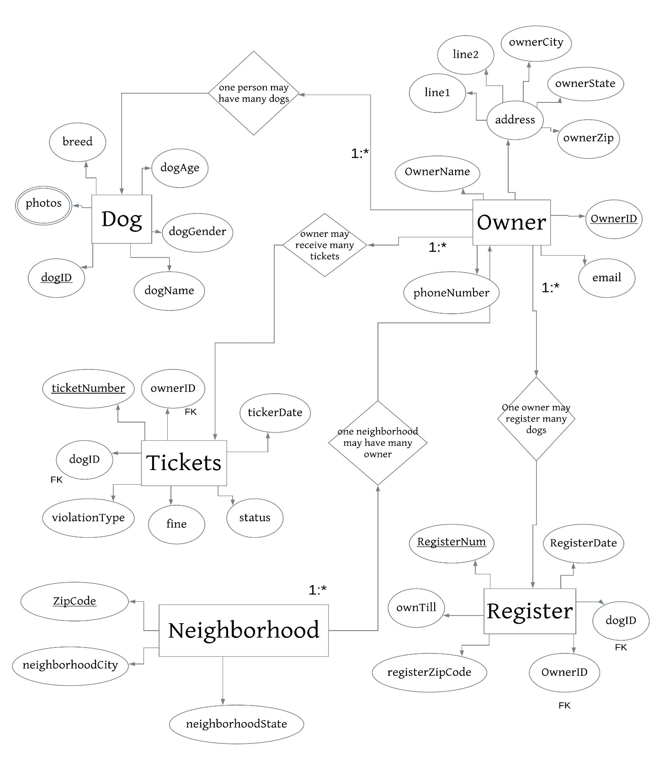

Entity Type:

Strong: Owner, Dog, Neighborhood

Weak: Register, Tickets

Entity Relationship

Dog (dogID, dogName, dogGender, dogAge, breed, photos)

Dog_Owner(dogID, ownerID)

Owner (ownerID, ownerName, phoneNumber, email, line1, line2, ownerCity, ownerState, ownerZip)

Neighborhood (zipCode, neighborhoodCity, neighborhoodState)

Tickets (ticketNumber, ownerID, ticketDate, dogID, violationType, fine, status)

Register (registerNum, registerDate, dogID, ownerID, registerZipCode, ownTill)

Questions

1. Identify dogs without violations in the last year. Display the owner name, dog name, breed and email.

A <= ᴨ dogID (Dog) - ᴨ dogID (ϭ Tickets.ticketDate >= 03/09/2017 (Owner_Ticket))

B <= ϭ A.dogID = regioster.dogID­ (A x Register)

C <= ϭ Owner.ownerID = B.ownerID (Owner x B)

Answer <= ᴨ ownerName, dogName, breed, email (C)

2. Identify neighborhoods without registered pit bulls today. Display the neighborhood.

A <= ϭ registerDate = 03/09/2017 (Register)

B <= ϭ dog.dogBreed = ‘Pit Bull’  (Dog x A)

C <= ᴨ zipCode (Neighborhood) - ᴨ registerZipCode (B)

Answer <= ᴨ neighborhoodCity, neighborhoodState, neighborhoodZip (C)

3. Identify owners without any registered dogs today. Display the owner name and email.

A <= ϭ ownTill ≠ Null (Register)

B <= ϭ owner.OwnerID = A.ownerID (Owner x A)

C <= ᴨ ownerName, email (B)

4. Identify owners who live near Queens College(Flushing) with registered dogs today. Display the owner name and email.

A <= ϭ ownTill ≠ Null (Register)

B <= ϭ neighborhoodCity = ‘Flushing’ (Neighborhood x A)

C <= ϭ ownerCity = B.neighborhoodCity (Owner x B)

Answer <= ᴨ ownerName, email (C)

5. Identify pictures of female poodles less than five years old. Display the dog name, age and photo(s).

A <= ϭ dogAge<5(Dog)

Answer <= ᴨ dogName, dogAge, photos(A)

6. Identify dogs owned by Bo Li with fines in the last year. Display the owner name, dog name, violation, date of violation and fine.

A <= ϭ ownerFirst = ‘Bo’ ownerLast = ‘Li’ (owner)

B <= ϭ A.ownerID = Tickets.OwnerID (A x Tickets)

C <= ϭ b.ticketDate>03/03/2017 (B)

D <= ϭ C.dogID = Dog.DogID (C x Dog)

Answer <= ᴨ ownerFirst, ownerLast, dogName, violationType, ticketDate, fine (C)

7. Identify the number of male dogs by dog name. Display two columns and one row for each dog name. The two output columns are dog name and number of dogs with that name. Use an aggregate function and grouping operation to answer this question.

A <= ϭ gender = ‘M’ (Dog)

B <= dogName ℑ count (dogID)(A)

Answer <= ρ answer (Dog Name, Number Of Male Dogs With This Name)(B)

8. Identify the number of poodles by neighborhood. Display two columns and one row for each neighborhood. The two output columns are zip code and number of poodles in that zip code. Use an aggregate function and grouping operation to answer this question.

A <= ϭ breed = ‘Poodle’ (Dog)

B <= ϭ A.dogID = Register.dogID (A x Register)

C <= zipCode ℑ count (dogID)(B)

Answer <= ρ answer (Zip Code, Poodle in This Area) (C)

9. Identify the number and total fines by owner. Display three columns and one row for each owner. The three columns are owner, number of violations and total dollar amount of fines. Use an aggregate function and grouping operation to answer this question.

A <= ϭ Owner.ownerID = Ticket.ownerID (Owner X Tickets)

B <= ownerID ℑ count (ticketNumber), sum (fine)(A)

Answer <= ρ answer (Owner ID, Number of Ticket, Amount of Fine)

10. Identify the number of registered female poodles in the database today. Display one row with the number of registered dogs.

A <= ϭ breed = ‘poodle’ ^ gender = ‘F’ (Dog)

Answer <= ρ answer (Female poodle) ℑ count(dogID)(A)